* North places
* New Delhi, NCR

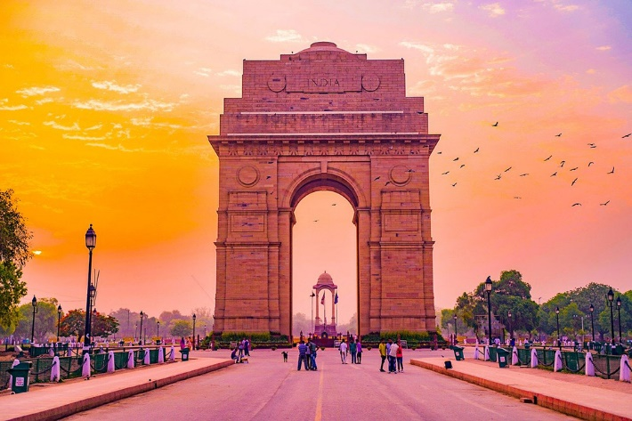

<https://www.your-space.in/wp-content/uploads/2020/08/top-10-places-to-live-in-delhi-ncr.jpg>

* The National Capital Region (NCR) is a planning region centred upon the National Capital Territory (NCT) of [Delhi](https://en.wikipedia.org/wiki/Delhi) in [India](https://en.wikipedia.org/wiki/India). It encompasses Delhi and several districts surrounding it from the states of [Haryana](https://en.wikipedia.org/wiki/Haryana), [Uttar Pradesh](https://en.wikipedia.org/wiki/Uttar_Pradesh) and [Rajasthan](https://en.wikipedia.org/wiki/Rajasthan). The NCR and the associated National Capital Region Planning Board were created in 1985 to plan the development of the region and to evolve harmonized policies for the control of land-uses and development of infrastructure in the region.[[5]](https://en.wikipedia.org/wiki/National_Capital_Region_(India)#cite_note-1985act-5) Prominent cities of NCR include [Delhi](https://en.wikipedia.org/wiki/Delhi), [Faridabad](https://en.wikipedia.org/wiki/Faridabad), [Ghaziabad](https://en.wikipedia.org/wiki/Ghaziabad), [Gurugram](https://en.wikipedia.org/wiki/Gurugram), and [Noida](https://en.wikipedia.org/wiki/Noida).
* Shimla, Himachal Pradesh

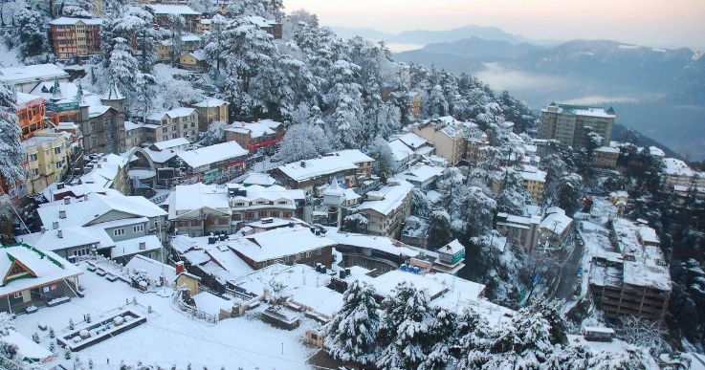

<https://s01.sgp1.digitaloceanspaces.com/large/866264-80013-jhamqgbpav-1516791727.jpg>

* The former summer capital of the British in India, and the present capital of Himachal Pradesh, Shimla has been blessed with all the natural bounties which one can think of. It has got a scenic location, it is surrounded by green hills with snow capped peaks. It’s also known for the handicraft shops that line The Mall, a pedestrian avenue, as well as the Lakkar Bazaar, a market specializing in wooden toys and crafts.
* Agra, Uttar Pradesh

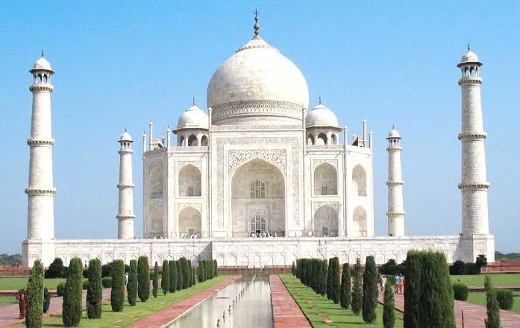

<https://thelandofwanderlust.com/wp-content/uploads/2017/06/DA7A14F5-E56A-4BB6-BCDA-40C631B0BCBD.jpeg>

* The Taj Mahal, is an ivory-white marble mausoleum on the right bank of the river Yamuna in the Indian city of Agra. It was commissioned in 1632 by the Mughal emperor Shah Jahan to house the tomb of his favourite wife, Mumtaz Mahal; it also houses the tomb of Shah Jahan himself. The Taj Mahal is considered to be the greatest architectural achievement in the whole range of Indo-Islamic architecture. The colour combination of lush green scape reddish pathway and blue sky over it show cases the monument in ever changing tints and moods. he most impressive in the Taj Mahal complex next to the tomb, is the main gate which stands majestically in the centre of the southern wall of the forecourt.
* Kullu and Manali, Himachal Pradesh

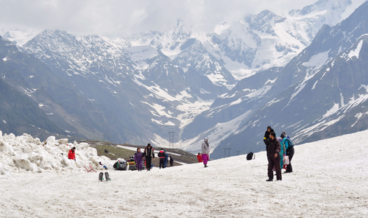

<https://5.imimg.com/data5/VF/NE/GLADMIN-59698317/kullu-manali-express-tour-500x500.png>

* Both Kullu and Manali, top tourist destinations of Himachal Pradesh, seem to outdo the other in their scenic magnificence and opportunities for sightseeing & adventure. Kullu, the town believed to be apt for the gods, pleasantly surprises the visitor with the diversity it offers. In Manali, what you see is what you get, raw beauty with serenity, the likes of which you may have only dreamt about. We are here to making it easy for tourists to plan for a unforgettable holidays in Kullu and Manali. During your stay in Himachal Pradesh, we also manage [Spiti Valley](https://www.kullu-manali.co.in/) Tour, [Leh Ladakh](https://www.kullu-manali.co.in/) and [Dharmshala](https://www.kullu-manali.co.in/) tour.
* Mussoorie and Dehradun, Uttarakhand

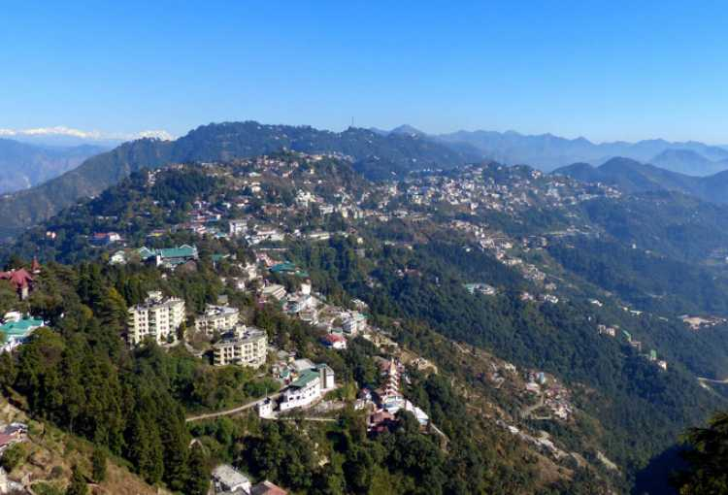

<https://www.euttaranchal.com/tourism/timthumb.php?src=https://www.euttaranchal.com/tourism/photos/mussoorie-325897.jpg&w=750&h=510&q=50>

* Mussoorie, also known as Queen of the Hills.Mussoorie is a hill station and a municipal board in the Dehradun district of the Indian state of Uttarakhand. It is about 35 kilometres from the state capital of Dehradun and 290 km north of the national capital of New Delhi. The hill station is in the foothills of the Garhwal Himalayan range. The best time to visit Mussoorie is during summers, as it offers respite from the scorching summer heat. However, if you are looking for a secluded holiday, come here during winters to witness the snowfall.
* Dalhousie, Himachal Pradesh

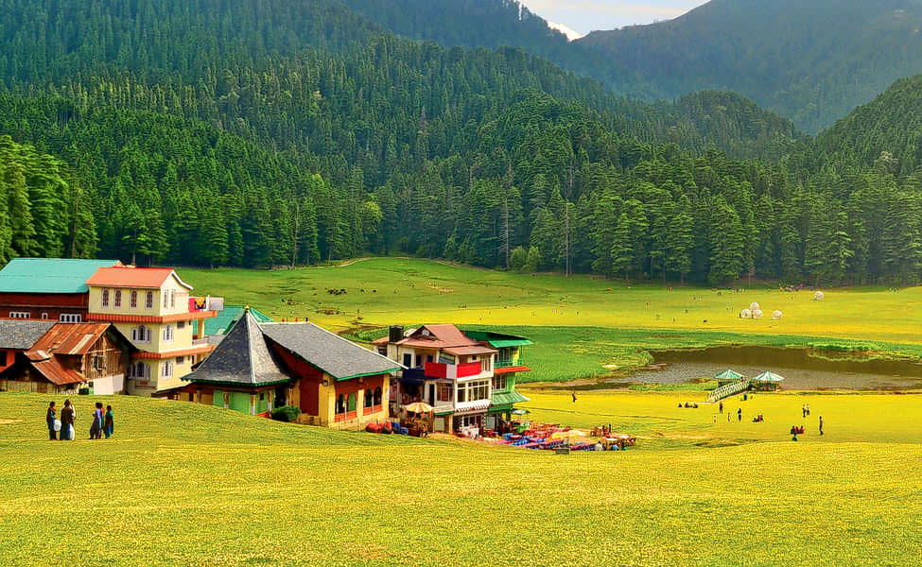

<https://images.thrillophilia.com/image/upload/s--6xOMHRRd--/c_fill,h_600,q_auto,w_975/f_auto,fl_strip_profile/v1/images/photos/000/112/340/original/1600316182_1587991355_1.Khajjiar-Mini-Switzerland-of-India-3.jpg.jpg.jpg?1600316182>

* Dalhousie is a high-altitude town spread across 5 hills near the Dhauladhar mountain range in the north Indian state of Himachal Pradesh. It's home to colonial-era buildings, including St. Francis and St. John’s churches, which date back to the rule of the British Raj in the 1800s.  Boasting views of the snow-capped peaks of Dhauladhar ranges, Dalhousie is famous for its meadows, dense jungles and waterfalls. A trek up Dainkund Peak leads to Pholani Devi Temple. To the north, Subhash Baoli is a peaceful area with pine trees and panoramic views
* Leh-Ladakh, Jammu, and Kashmir
* 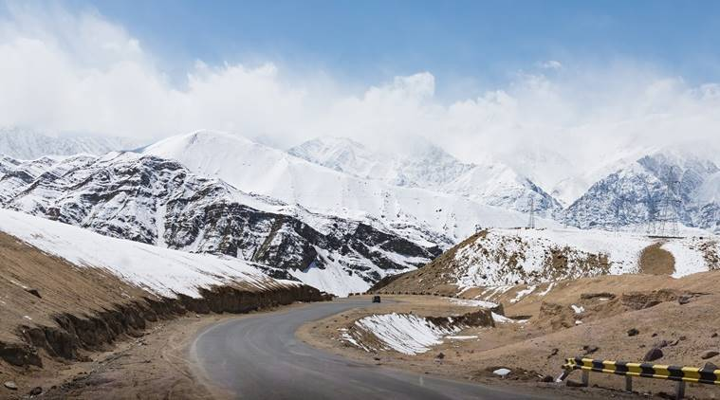

<https://images.indianexpress.com/2019/01/leh-ladakh-getty-images-759.jpg>

* The largest town in Ladakh is Leh, followed by Kargil, each of which headquarters a district. The Leh district contains the Indus, Shyok and Nubra river valleys. ... Ladakh was established as a union territory of India on 31 October 2019, following the passage of the Jammu and Kashmir Reorganisation Act. The largest town in Ladakh is [Leh](https://en.wikipedia.org/wiki/Leh" \o "Leh), followed by [Kargil](https://en.wikipedia.org/wiki/Kargil" \o "Kargil), each of which headquarters a district.[[16]](https://en.wikipedia.org/wiki/Ladakh#cite_note-17) The [Leh district](https://en.wikipedia.org/wiki/Leh_district" \o "Leh district) contains the [Indus](https://en.wikipedia.org/wiki/Indus_River), [Shyok](https://en.wikipedia.org/wiki/Shyok_River" \o "Shyok River) and [Nubra](https://en.wikipedia.org/wiki/Nubra_River" \o "Nubra River) river valleys. The [Kargil district](https://en.wikipedia.org/wiki/Kargil_district" \o "Kargil district) contains the [Suru](https://en.wikipedia.org/wiki/Suru_River_(Indus)" \o "Suru River (Indus)), [Dras](https://en.wikipedia.org/wiki/Dras_River" \o "Dras River) and [Zanskar](https://en.wikipedia.org/wiki/Zanskar_River) river valleys. The main populated regions are the river valleys, but the mountain slopes also support the pastoral [Changpa](https://en.wikipedia.org/wiki/Changpa" \o "Changpa) nomads.
* Kasol, Himachal Pradesh

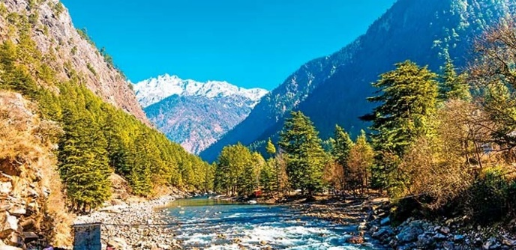

<https://images.thrillophilia.com/image/upload/s--HmRdvBUI--/c_fill,h_775,q_auto,w_1600/f_auto,fl_strip_profile/v1/images/photos/000/089/998/original/1466491434_x140515163940-Kasol2.jpg.pagespeed.ic.LlpoGzNqTU.jpg.jpg?1466491434>

* Kasol is a hamlet in the district Kullu of the Indian state of Himachal Pradesh. It is situated in Parvati Valley, on the banks of the Parvati River, on the way between Bhuntar and Manikaran. It is located 30 km from Bhuntar and 3.5 km from Manikaran. Kasol has good weather for several months of the year and receives a fair amount of snowfall from late December to February. Kasol is the Himalayan hotspot for backpackers. and acts as a base for nearby treks to [Malana](https://en.wikipedia.org/wiki/Malana,_Himachal_Pradesh" \o "Malana, Himachal Pradesh) and [Kheerganga](https://en.wikipedia.org/wiki/Parvati_Valley" \o "Parvati Valley). It is called Mini Israel of India due to a high percentage of Israeli tourists here.
* Spiti, Himachal Pradesh

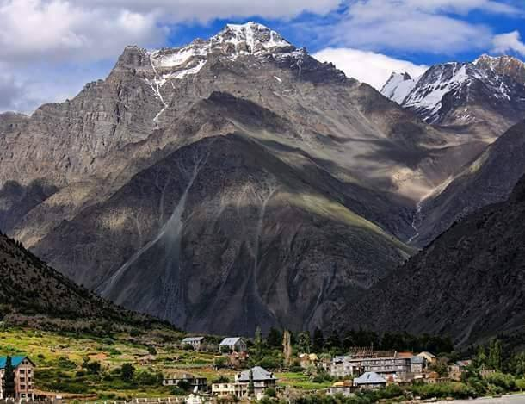

<https://i0.wp.com/www.himbuds.com/wp-content/uploads/2017/05/Lahaul_Spiti.jpg?fit=610%2C469>

* Spiti Valley is a cold desert mountain valley located high in the Himalayas in the north-eastern part of the northern Indian state of Himachal Pradesh. The name "Spiti" means "The middle land", i.e. the land between Tibet and India. The valley and surrounding region are among the least populated regions in [India](https://en.wikipedia.org/wiki/India). Spiti valley is a gateway to the northernmost reaches of the nation.
* Kedarnath, Uttarakhand

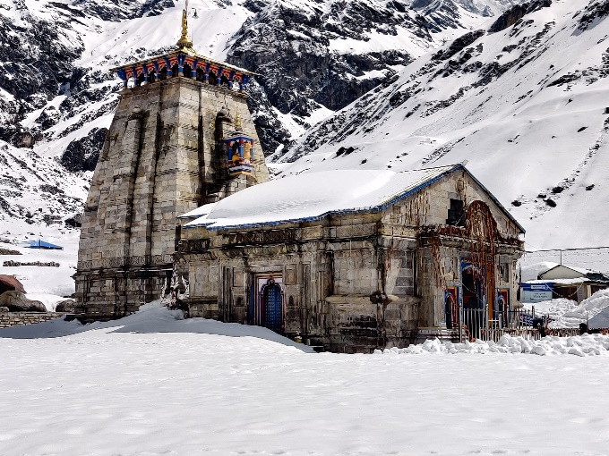

<https://badrinath-kedarnath.gov.in/Assets/image/k3.jpg>

* Kedarnath Temple is a [Hindu temple](https://en.wikipedia.org/wiki/Hindu_temple) (shrine) dedicated to the Hindu God [Shiva](https://en.wikipedia.org/wiki/Shiva). The temple is located on the Garhwal [Himalayan range](https://en.wikipedia.org/wiki/Himalayan_range) near the [Mandakini river](https://en.wikipedia.org/wiki/Mandakini_river" \o "Mandakini river), in the state of [Uttarakhand](https://en.wikipedia.org/wiki/Uttarakhand), [India](https://en.wikipedia.org/wiki/India). Due to [extreme weather](https://en.wikipedia.org/wiki/Extreme_weather) conditions, the temple is open to the general public only between the months of April ([Akshaya Tritiya](https://en.wikipedia.org/wiki/Akshaya_Tritiya)) and November ([Kartik Purnima](https://en.wikipedia.org/wiki/Kartik_Purnima), the autumn full moon). During the winters, the vigraha (deity) from Kedarnath temple is carried down to [Ukhimath](https://en.wikipedia.org/wiki/Ukhimath" \o "Ukhimath) where the deity is worshiped for the next six months. Kedarnath is seen as a homogenous form of [Shiva](https://en.wikipedia.org/wiki/Shiva), the 'Lord of Kedarkhand', the historical name of the region.  The temple is one of the four major sites in India's [Chota Char Dham](https://en.wikipedia.org/wiki/Chota_Char_Dham" \o "Chota Char Dham) pilgrimage of Northern Himalayas and is the first of the [Panch Kedar](https://en.wikipedia.org/wiki/Panch_Kedar" \o "Panch Kedar) pilgrimage sites.
* Nubra vally, jammu & Kashmir

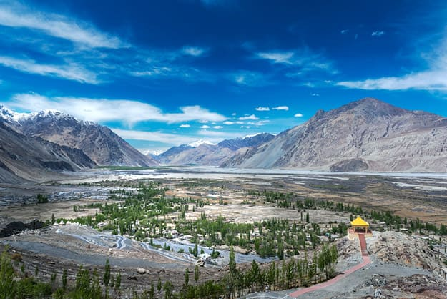

<https://static.india.com/wp-content/uploads/2018/08/Nubra-Valley-1-1.jpg>

* Nubra, also called Dumra, is a historical region of [Ladakh](https://en.wikipedia.org/wiki/Ladakh" \o ").NUBRA VALLEY TOURISM. Known for its orchards, scenic vistas, Bactrian camels and monasteries; Nubra Valley is the northernmost part of Jammu and Kashmir. Situated about 150 km from Leh, Nubra Valley is known as the Orchard of Ladakh and was originally called Ldumra which meant the valley of flowers. The village of [Turtuk](https://en.wikipedia.org/wiki/Turtuk" \o "Turtuk) which was unseen by tourists till 2010 is a virgin destination for people who seek peace and an interaction with a tribal community of Ladakh. The local tribe, [Balti people](https://en.wikipedia.org/wiki/Balti_people), follows its age old customs in their lifestyle and speak a language which is just spoken and not written. For tourists [Turtuk](https://en.wikipedia.org/wiki/Turtuk" \o "Turtuk) offers serene camping sites with environment friendly infrastructure.
* Khajjiar, Himachal Pradesh

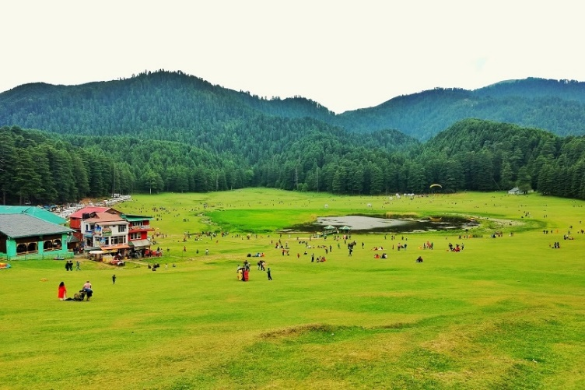

<https://www.oyorooms.com/travel-guide/wp-content/uploads/2019/06/Image-1-20.jpg>

* Khajjiar is a hill station in the north Indian state of Himachal Pradesh. Dating from the 12th century, Khajji Nag Temple is dedicated to a serpent god. Nearby, the high-altitude Khajjiar Lake is surrounded by cedar forest. West, Kalatop Wildlife Sanctuary is home to animals including deer and bears. Farther west, Dalhousie is a hill station with mountain views, dotted with temples and 19th-century British churches. Khajjiar is famous for the popular Khajji Naga shrine dedicated to the serpent god from which the name is believed to have been derived. The temple dates back to the 10th century and is interspaced with different patterns and images on the ceiling and wooden posts.
* South places
* Coorg, Karnataka

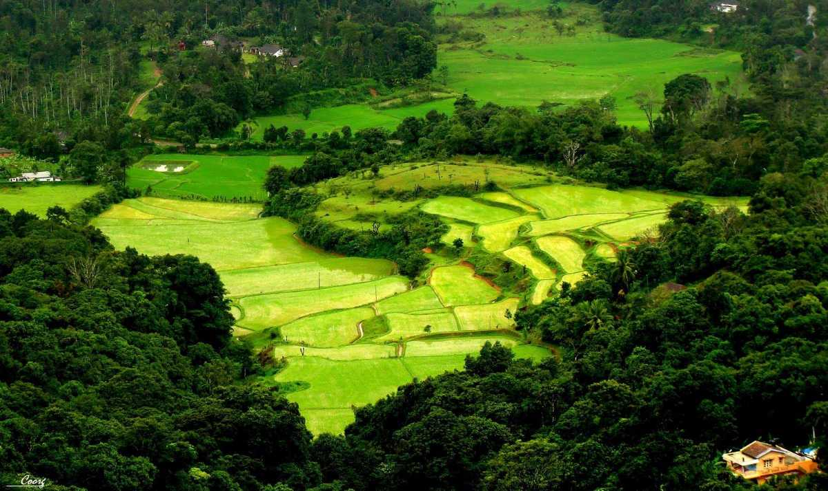

<https://www.holidify.com/images/bgImages/COORG.jpg>

* Located amidst imposing mountains in Karnataka with a perpetually misty landscape, Coorg is a popular coffee producing hill station. It is popular for its beautiful green hills and the streams cutting right through them. It also stands as a popular destination because of its culture and people. The Kodavas, a local clan specializing in martial arts, are especially notable for their keen hospitality.Coorg, officially known as Kodagu, is the most affluent hill station in Karnataka. It is well known for its breathtakingly exotic scenery and lush greenery. Forest covered hills, spice and coffee plantations only add to the landscape.
* Kodaikanal, Tamil Nadu

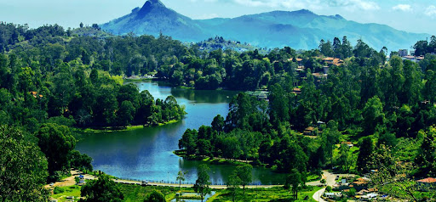

<https://lh3.googleusercontent.com/proxy/ZkaQ0hGwIoZVJPuDEea3BVjCBLsIuCr2sYns0DgX4xUd2EHfKAFofUxR0cSTXlVyZJU6GyIMsaFkZ4kMDpjdDXBHo-zOIGnMGhUSsfXZu6yL9ceXnH1wdEUX3wk7At8eT53MMB4>

* Kodaikanal is a hill town in the southern Indian state of Tamil Nadu. It’s set in an area of granite cliffs, forested valleys, lakes, waterfalls and grassy hills. At 2,000 meters above sea level, the town centers around man-made, star-shaped Kodaikanal Lake, bordered by evergreen forest. Rowing boats can be hired, and hikers and cyclists follow the 5k Lake Road path around the shore. Nestled amidst the rolling slopes of the Palani Hills, Kodaikanal stands at an altitude of 7200 feet above sea level, and once you visit this hill station, you will find that every bit of what you have imagined it to be is real. Kodaikanal is a place you can go to take a break from the rigours of daily city life, and this hill station lets you sit back and connect with nature as you head out on biking or trekking trails or take a stroll through the vast forests surrounding the town.
* Thekkady, kerala

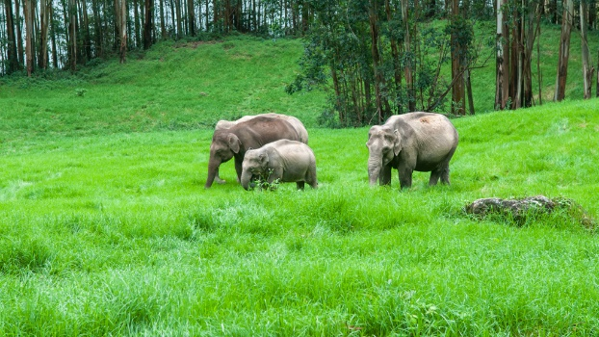

<https://www.ekeralatourism.net/wp-content/uploads/2019/01/places-to-visit-thekkady.jpg>

* Thekkady is a town near Periyar National Park, an important tourist attraction in the Kerala state of India. The named Thekkady is derived from the word "thekku" which means teak. This place experiences a pleasant climate all over the year. There are many resorts near the national park and an early boat safari within the sanctuary is amust to be able to spot wild elephants, bisons, wild boars, various kinds of birds, etc. Thekkady is considered a haven for natural [spices](https://en.wikipedia.org/wiki/Spice) such as [black pepper](https://en.wikipedia.org/wiki/Black_pepper), [cardamom](https://en.wikipedia.org/wiki/Cardamom), [cinnamon](https://en.wikipedia.org/wiki/Cinnamon), [nutmeg](https://en.wikipedia.org/wiki/Nutmeg), nutmace, [ginger](https://en.wikipedia.org/wiki/Ginger), and [clove](https://en.wikipedia.org/wiki/Clove).
* Hydrabad, Telangana

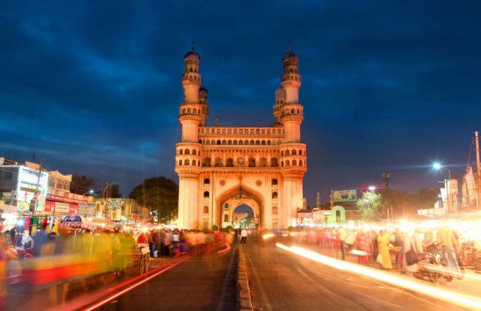

<https://www.treebo.com/blog/wp-content/uploads/2018/05/15-Unique-Things-to-Do-at-Night-in-Hyderabad-1024x662.jpg>

* The capital city of Telangana, Hyderabad is a popular tourist destination and presents its visitors with a mesmerising contrast of age old traditions, culture at one end and modern facilities, amenities of a metropolitan city at the other end. Hyderabad is one city, which has no dearth of **tourist attractions**.
* Araku valley,Andhra Pradesh

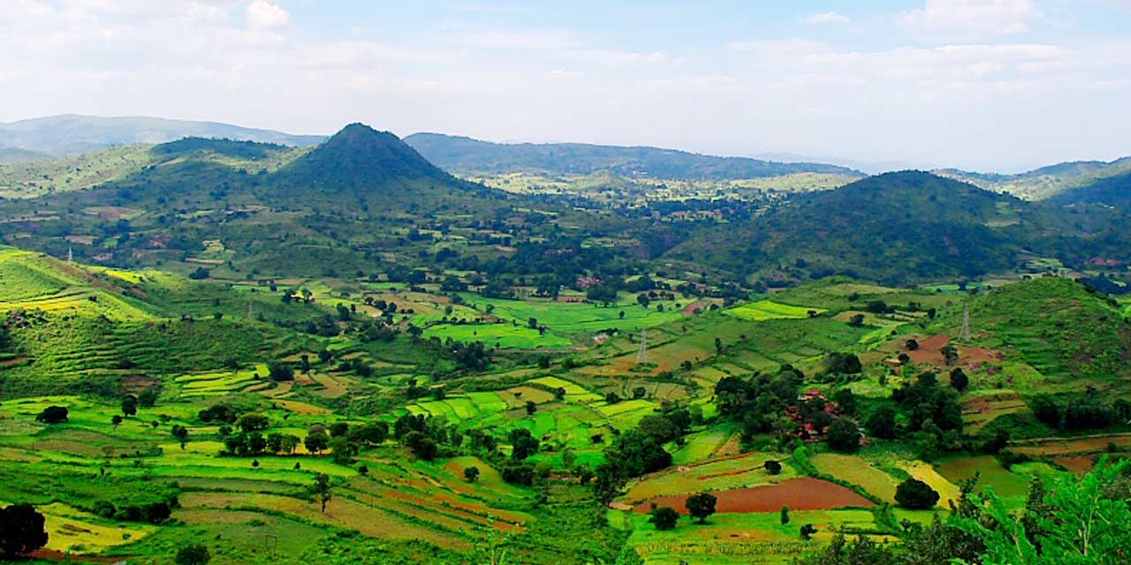

<https://vizagtourism.org.in/images/places-to-visit/header/araku-valley-vizag-tourism-entry-fee-timings-holidays-reviews-header.jpg>

* Araku Valley is a hill station and valley region in the southeastern Indian state of Andhra Pradesh. It's surrounded by the thick forests of the Eastern Ghats mountain range. The Tribal Museum is dedicated to the area's numerous indigenous tribes, known for their traditional Dhimsa dance, and showcases traditional handicrafts. A miniature train runs through Padmapuram Gardens, with its sculptures and tree-top huts. Vizag is a popular tourist destination mainly known for its beaches. Located at a distance of 120 km from Vizag is a beautiful hill station called Araku which is as popular as the beaches of Vizag.
* Wayanad, kerala

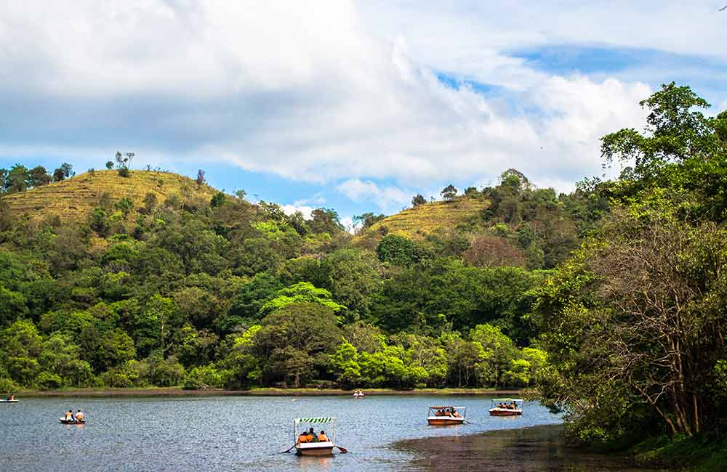

<https://www.fabhotels.com/blog/wp-content/uploads/2019/09/Wayanad-1.jpg>

* Wayanad, one of the most visited hill stations in [Kerala](https://www.fabhotels.com/blog/india-tourism/kerala-tourism/), beckons trekking enthusiasts and nature lovers. Its rolling hills and lush green forests are home to a number of animals and birds. After the monsoons, the waterfalls too come alive with a renewed spirit. The dams and lakes in Wayanad are ideal for an afternoon picnic. And then there are the temples and caves waiting to be explored. In the east, the Wayanad Wildlife Sanctuary is a lush, forested region with areas of high altitude, home to animals including Asiatic elephants, tigers, leopards and egrets.
* Gokarna, Karnataka

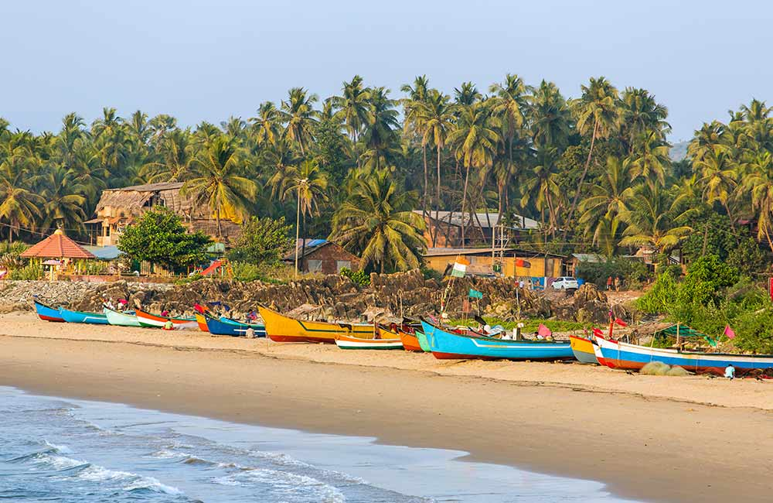

<https://www.fabhotels.com/blog/wp-content/uploads/2019/09/Gokarna-1.jpg>

* Gokarna, a Hindu pilgrimage site in Karnataka, is best known for its beautiful beaches with white sand and swaying coconut palms. Apart from the beaches, Gokarna has a number of old and new temples. It is considered one of the popular tourist places for solo travelers in South India. Since the town has religious significance, there are a number of vegetarian-only restaurants but seafood places and a bar to relax in are not very hard to find. The town is also home to beaches such as palm-lined Gokarna, in the center, plus Kudle and Om farther south. Palm clad beaches are dotted with foreign tourists in a majority and very few Indians are seen across. Gokarna is not very conventionally touristy. The beaches are meant for a slow, relaxed holiday and everything on the beach goes at the same relaxed pace.
* Hampi, Karnataka

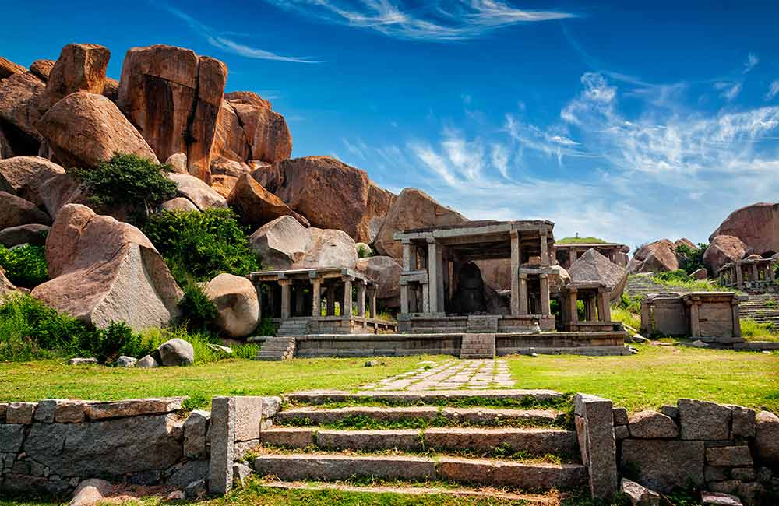

<https://www.fabhotels.com/blog/wp-content/uploads/2019/09/Hampi-1.jpg>

* Hampi or Hampe, also referred to as the Group of Monuments at Hampi, is a [UNESCO](https://en.wikipedia.org/wiki/UNESCO) [World Heritage Site](https://en.wikipedia.org/wiki/World_Heritage_Site) located in east-central [Karnataka](https://en.wikipedia.org/wiki/Karnataka), India. Hampi is one of the top places to visit in South India. The world heritage site takes visitors back in time to the 15th and 16th century with its magnificent ruins. It makes everyone’s imagination come alive with remnants of temples, monuments, and havelis. Quaint cafes set up on rooftops offer a variety of cuisines and are the ideal places to spend the evening. A carved stone chariot stands in front of the huge Vittala Temple site. Southeast of Hampi, Daroji Bear Sanctuary is home to the Indian sloth bear.
* Mahabalipuram, Tamil nadu

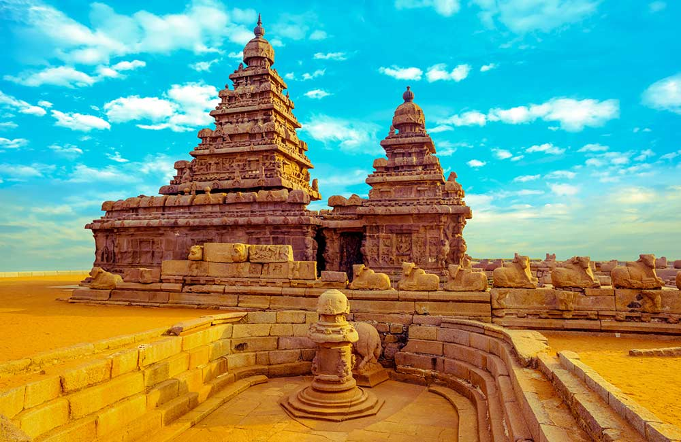

<https://www.fabhotels.com/blog/wp-content/uploads/2019/09/Mahabalipuram-1.jpg>

* Mahabalipuram, once a major seaport, is now a must-visit World Heritage Site on every history buff’s bucket list. From carved relief work on stone to cave temples, Mahabalipuram overflows with architectural wonders. Sunsets are extra special here as the soft glow of the setting sun adds to the allure of these monuments. And then there’s the mystery of Krishna’s Butterball. The city’s proximity to Chennai makes it one of the popular long weekend destinations in South India. Krishna’s Butter Ball is a massive boulder balanced on a small hill near the Ganesha Ratha stone temple.
* pondicherry, Puducherry

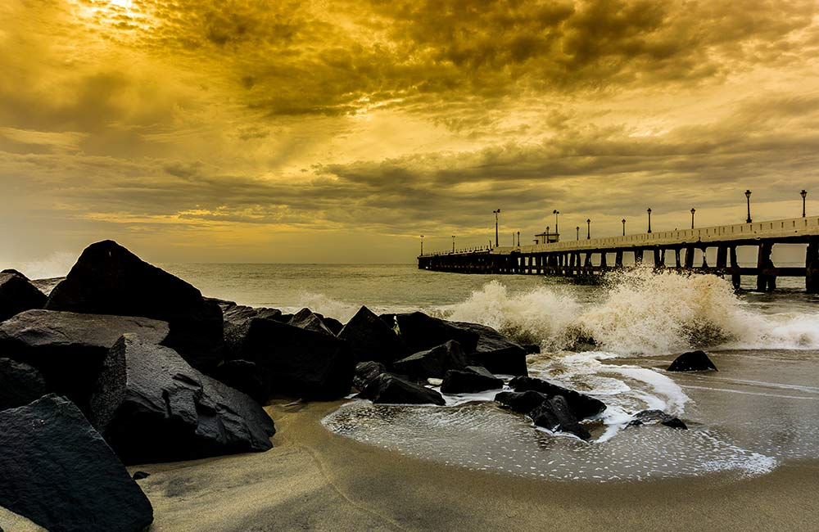

<https://www.fabhotels.com/blog/wp-content/uploads/2019/09/Pondicherry-1.jpg>

* Pondicherry is one of the few places in India that reflects the contribution French culture made to our heritage. On one hand, Pondicherry boasts of villas with teak columned courtyards and vibrant yellow walls and on the other is the peaceful aura of Auroville. Its respectful and safe culture and bohemian vibe have made this city one of the top **tourist places for solo travelers in South India**. There are also a number of beaches here where you can easily watch.
* Kumarakom, kerala

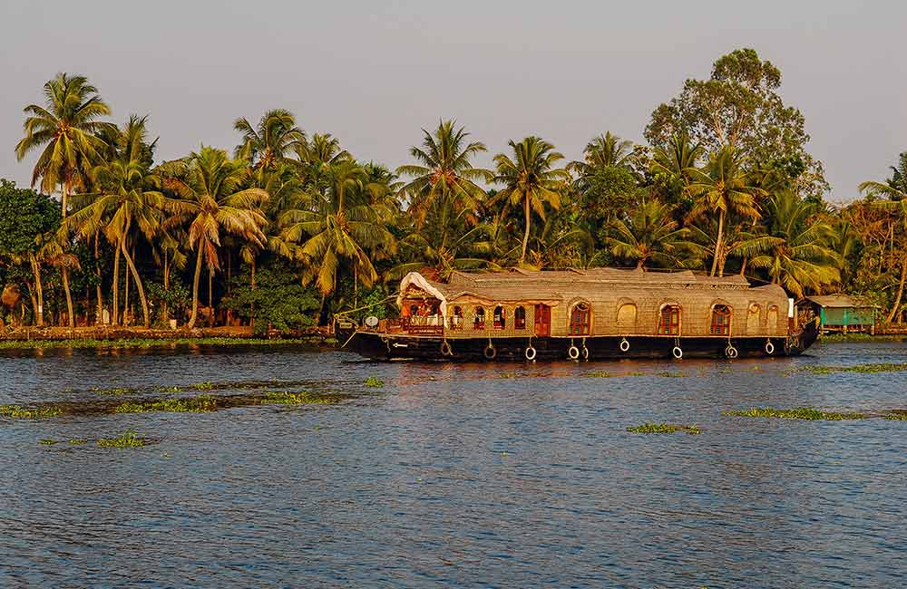

<https://www.fabhotels.com/blog/wp-content/uploads/2019/09/Kumarakom-Kerala-1.jpg>

* With its beautiful blue lake, picturesque villages and bird sanctuary, Kumarakom is a nature lover’s delight and one of the top **weekend destinations in South India**. Whether you’re here for the weekend or the whole week, there’s plenty to do here such as an overnight stay on a houseboat, night fishing, cruising down the backwaters in a shikara, and birdwatching. If you’re craving a simple life, Kumarakom the place you need to be.
* Kanyakumari, Tamil nadu

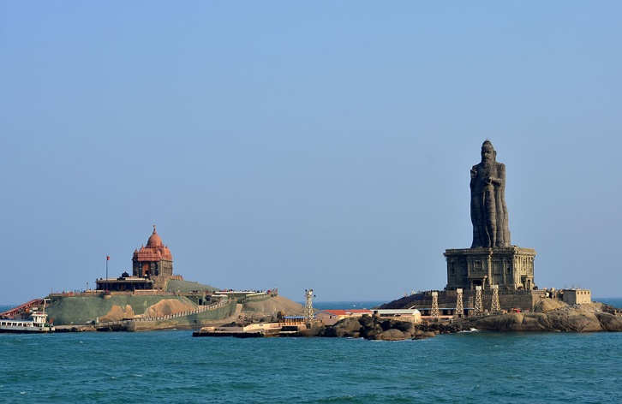

<https://www.fabhotels.com/blog/wp-content/uploads/2019/09/Kanyakumari-1.jpg>

* The southernmost tip of the Indian mainland, Kanyakumari is famed for its spectacular sunrises and sunsets over the Bay of Bengal, the Arabian Sea, and the Indian Ocean. Kanyakumari is a small town that makes a big impact. During the day between these glorious moments, there are forts, churches, and temples to be visited and paddy fields to be photographed. A few minutes at the Vivekananda Rock Memorial can transport you to a whole new world.
* East places
* Kaziranga National park, assam

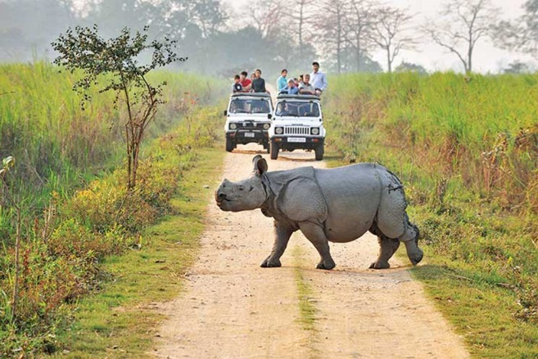

<https://nenow.in/wp-content/uploads/2019/10/3-9.jpg>

* This undisturbed acres long stretch of forests and marshlands is located in the heart of Assam and is visited by hordes of tourists every year and it is one of the famous places to visit in No
* rth East India. The notable one-horned Rhino is a major attraction in Kaziranga which is an endangered species in the world.

* Tsomgo lake , Sikkim

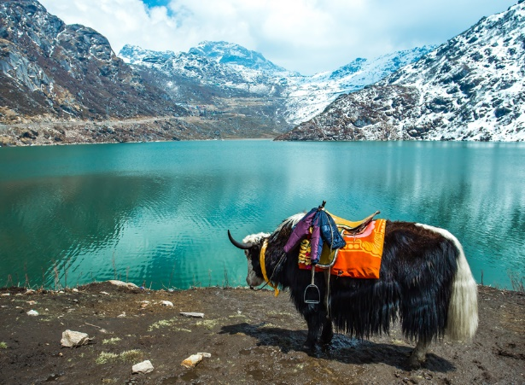

<https://www.esikkimtourism.in/wp-content/uploads/2019/04/tsomgosptmbr.jpg>

* The winding roads which make a 37 km long journey from Gangtok to reach an altitude of 12,400 ft are ethereally beautiful and it is one of the best places to visit in North East India the lake at such an elevation flaunts its stillness in the most surreal settings of Himalayan peaks encircling it.
* Ziro valley, Arunachal Pradesh

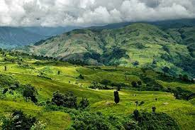

<https://www.onhisowntrip.com/wp-content/uploads/2020/06/ziro.jpg>

* Ziro Valley is the flat land amidst the sky jutted mountains with around five villages where the highest population is of the Apatani tribe. This tribe is friendly and Ziro serves as a perfect ground for celebrating the music fest every year. The verdant rice field, the in-line tribal huts, the vibrant and colourful attires and accessories of the Tribal people and it is one of the best places to visit in North East India.
* Goechala, Sikkim

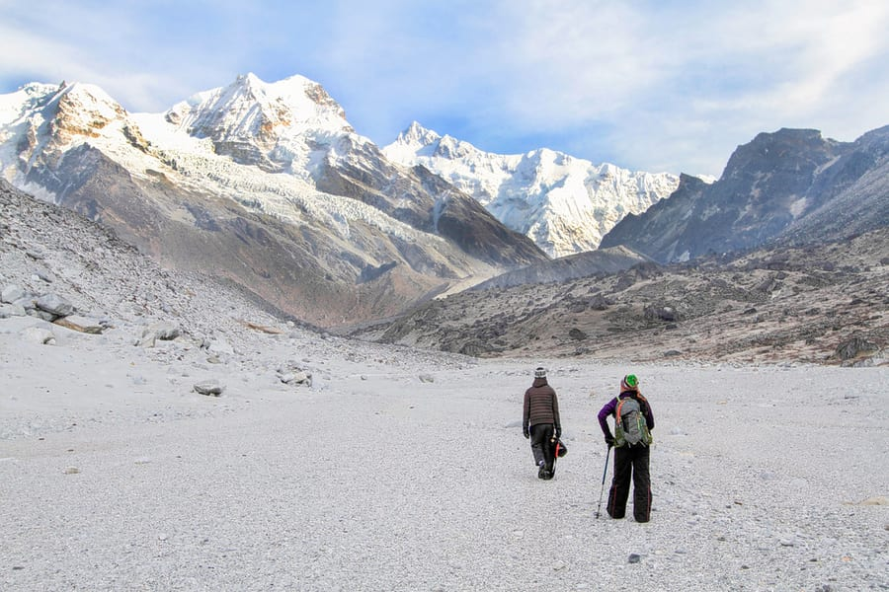

<https://res.cloudinary.com/thrillophilia/image/upload/c_fill,f_auto,fl_progressive.strip_profile,g_auto,h_600,q_auto,w_auto/v1/filestore/mfa0j5ezq3a6maqne9717b4ixuli_1580723208_shutterstock_146766587.jpg>

* This is a ‘must-do’ trek in Sikkim and the fact that you encounter the big mountains of Himalayan range face-to-face keeps the trail flocked throughout the spring season. The Goechala trek enables trekkers to witness the magnanimous Himalayan summits, more than 14 in number.
* Cherrapunji and mawsynram, Meghalaya

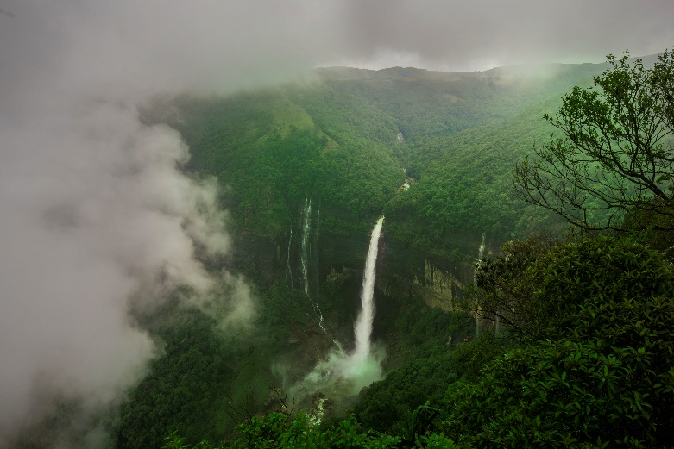

<https://upload.wikimedia.org/wikipedia/commons/b/bb/Nohkalikai_Falls%2C_Cherrapunji.jpg>

* These are the wettest places in India and both are located within a distance of 16 km. However, Mawsynram is the wettest among both with a recorded annual rainfall of 11,872 millimetres, making Cherrapunji the second wettest place in India that receives an average annual rainfall of 11,777 millimetres and it is one of the best places to visit in North East India.
* Siang River Rafting, Arunachal Pradesh

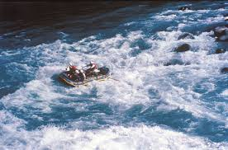

<https://encrypted-tbn0.gstatic.com/images?q=tbn:ANd9GcSn89dlGkYzPJPcvwcWcBEFQTCjBu2-p1lZmg&usqp=CAU>

* From moderate to difficult rapids, river Siang gives you the adventure to row your rafts in grade 3 and 4 level rapids and riffles. The river is wild and the rafts see huge drops with raging speed, thrilling the rafters to the core.
* Pelling, Sikkim

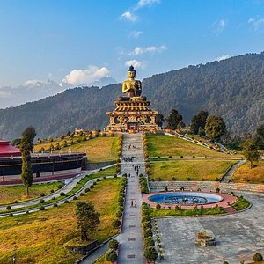

<https://dynamic-media-cdn.tripadvisor.com/media/photo-o/1b/b0/6a/5c/caption.jpg?w=300&h=300&s=1>

* Pelling is gaining popularity with each passing year and the next big attraction after Gangtok. Pelling is a town in the West district of Sikkim at an elevation of 2000 meters and is a paradise for peace-seekers. You can indulge in activities like rock climbing, mountain biking, village walks etc.
* mawsmai, cave

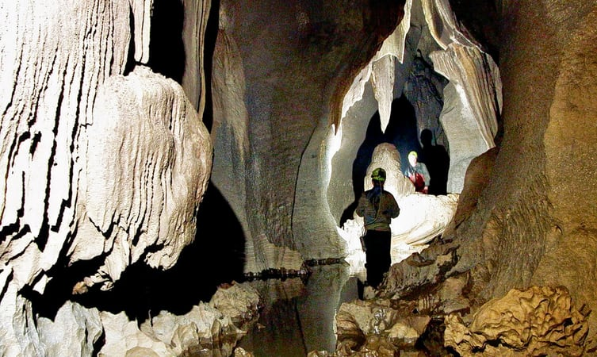

<https://images.thrillophilia.com/image/upload/s--WGRoq3KT--/c_fill,g_center,h_450,q_auto,w_753/dpr_1.0,f_auto,fl_strip_profile/v1/images/photos/000/128/899/original/1529317626_1.jpg.jpg>

* This cave is one of the many caves in Northeast India which has enough light passing for the travellers to see the limestone structures and uneven walls.
* This natural marvel has undergone years of abrasion and underground water exposures that the stalactites and stalagmites are carved out in a various structure that leaves you spellbound. Being the only lit cave in Meghalaya, Mawsmai cave is a crowd puller.
* Narunang falls

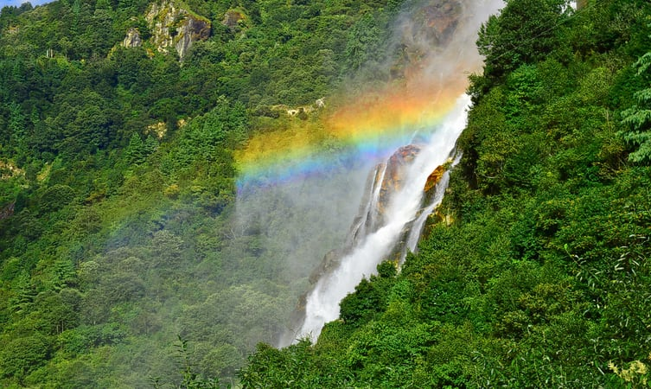

<https://images.thrillophilia.com/image/upload/s--6Cly1N0s--/c_fill,g_center,h_450,q_auto,w_753/dpr_1.0,f_auto,fl_strip_profile/v1/images/photos/000/128/854/original/1532438900_shutterstock_728730616.jpg.jpg>

* Plummeting from an elevation of about 100 meters, Nuranang falls is a pristine waterfall hidden in the thick forest stretches on your journey from Tawang to Bomdila. This virgin waterfall is famous as BTK, Bap Teng Kang waterfalls and can be located on the way through Tawang towards Zemithang.
* Tripura sundari temple

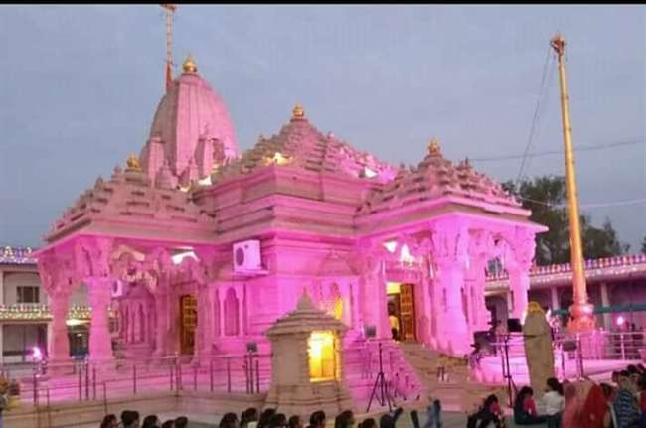

<https://www.jagranimages.com/images/newimg/30092019/30_09_2019-tripurasundaritemple_19626766.jpg>

* Tripura Sundari Temple is a Hindu temple of Goddess Tripura Sundari, better known locally as Devi Tripureshwari. The temple is situated in the ancient city of Udaipur, about 55 km from Agartala, Tripura and can be reached by train and road from Agartala.
* Jaintia hills, Meghalaya

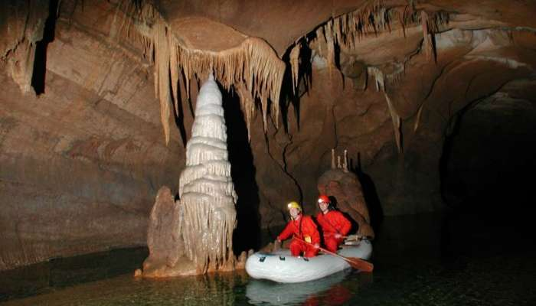

<https://img.traveltriangle.com/blog/wp-content/tr:w-700,h-400/uploads/2015/01/Jaintia-Hills1.jpg>

* Located in the heart of Meghalaya, Jaintia Hills are stuffed with limestone deposits and are one of the top north east tourist attractions. The hills have a number of caves for the explorer in you to enjoy and soothe your mind. Spelunking in these caves can lead you to a number of shallow and some long caves, making it an adventurous attraction in the region. Though, it’s best to have company during this adventure for a memorable experience.
* Nathula pass, Sikkim

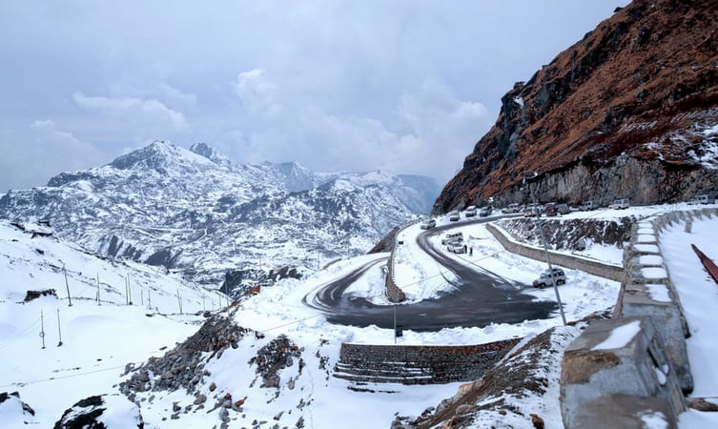

<https://images.thrillophilia.com/image/upload/s--ZX6elEKk--/c_fill,g_center,h_450,q_auto,w_753/dpr_1.0,f_auto,fl_strip_profile/v1/images/photos/000/128/903/original/1529318043_shutterstock_1040258842.jpg.jpg>

* The old silk road that once used by merchants and traders is at an elevation of 14450 ft. above sea level on the Indo-Tibetan border. The temperature at Nathula is always freezing regardless of the season and the entire region is rich in Himalayan flora and fauna. It is one of the famous places to visit in North East India can be easily travelled from the capital city Gangtok.
* West places
* Kutch, Gujrat – the White desert of india

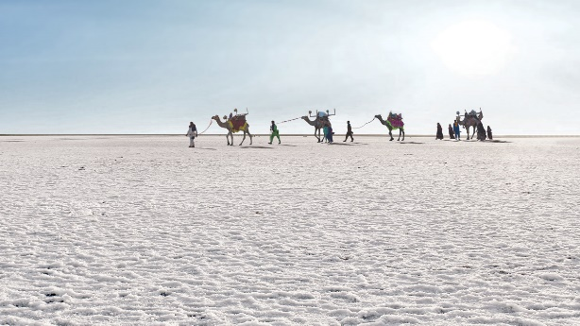

<https://visitwhiterann.com/wp-content/uploads/2017/01/rannutsav-white.jpg>

* The Rann of Kachchh is a salt marshy land in the Thar Desert in the Kachchh district of western Gujarat. It lies between Gujarat in India and the Sindh province in Pakistan. It comprises of around 30,000 sq. km of land which includes The Great Rann of Kachchh, The Little Rann of Kachchh and Banni grassland.
* Ajanta and ellora caves, Maharashtra

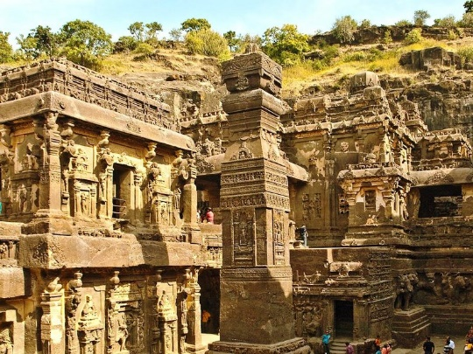

<https://i1.wp.com/www.tusktravel.com/blog/wp-content/uploads/2020/02/rock-sculpture.jpg?resize=800%2C600&ssl=1>

* The Buddhist Caves in Ajanta are approximately 30 [rock-cut](https://en.wikipedia.org/wiki/Rock_cut_architecture) [Buddhist cave monuments](https://en.wikipedia.org/wiki/Buddhist_caves_in_India) dating from the 2nd century [BCE](https://en.wikipedia.org/wiki/Common_Era) to about 480 CE in the [Aurangabad district](https://en.wikipedia.org/wiki/Aurangabad_district,_Maharashtra) of [Maharashtra](https://en.wikipedia.org/wiki/Maharashtra) state in [India](https://en.wikipedia.org/wiki/India). The caves include paintings and rock-cut sculptures described as among the finest surviving examples of [ancient Indian art](https://en.wikipedia.org/wiki/Ancient_Indian_architecture), particularly expressive paintings that present emotions through gesture, pose and form
* Gir, Gujrat

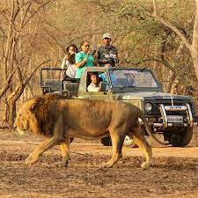

<https://encrypted-tbn0.gstatic.com/images?q=tbn:ANd9GcQOqtYnMcCk4kZszxB6NiSRAOaIob0ZlvRfRv5amkFScjIP2C0RcihzaE2JEgwjUie-gNo&usqp=CAU>

* Gir National Park and Wildlife Sanctuary, also known as Sasan Gir, is a forest, [national park](https://en.wikipedia.org/wiki/National_park), and [wildlife sanctuary](https://en.wikipedia.org/wiki/Wildlife_sanctuary) near [Talala Gir](https://en.wikipedia.org/wiki/Talala_(Gir)" \o "Talala (Gir)) in [Gujarat](https://en.wikipedia.org/wiki/Gujarat), India. It is located 43 km (27 mi) north-east of [Somnath](https://en.wikipedia.org/wiki/Somnath), 65 km (40 mi) south-east of [Junagadh](https://en.wikipedia.org/wiki/Junagadh) and 60 km (37 mi) south-west of [Amreli](https://en.wikipedia.org/wiki/Amreli). It was established in 1965 in the erstwhile [Nawab of Junagarh](https://en.wikipedia.org/wiki/Nawab_of_Junagarh)'s private hunting area, with a total area of 1,412 km2 (545 sq mi), of which 258 km2 (100 sq mi) is fully protected as national park and 1,153 km2 (445 sq mi) as wildlife sanctuary. It is part of the [Khathiar-Gir dry deciduous forests](https://en.wikipedia.org/wiki/Khathiar-Gir_dry_deciduous_forests" \o "Khathiar-Gir dry deciduous forests) [ecoregion](https://en.wikipedia.org/wiki/Ecoregion).
* Mahabaleshwar – the land of strawberries

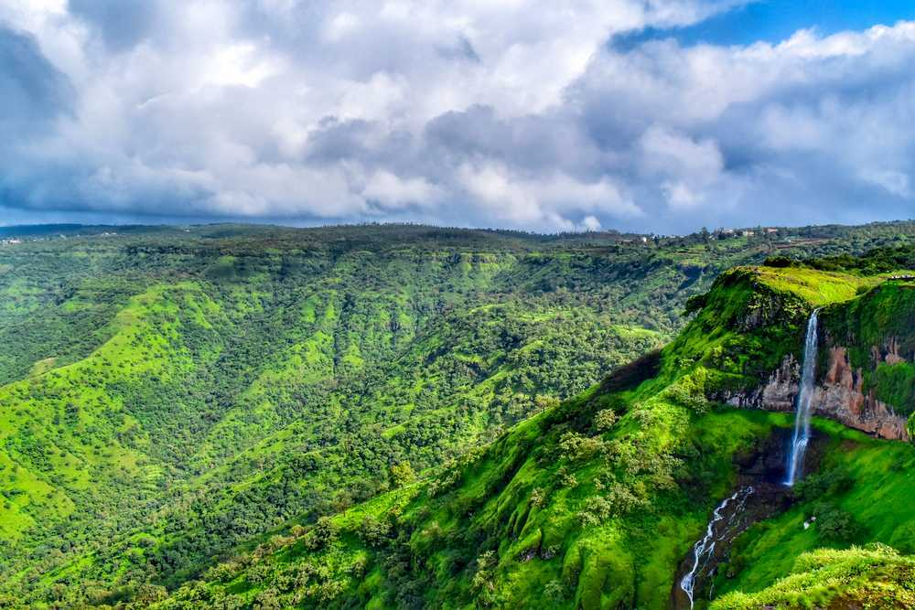

<https://www.holidify.com/images/bgImages/MAHABALESHWAR.jpg>

* **Mahabaleshwar** is a small town and a [municipal council](https://en.wikipedia.org/wiki/Municipal_council) in [Satara district](https://en.wikipedia.org/wiki/Satara_district" \o "Satara district) in the [Indian](https://en.wikipedia.org/wiki/India) [state](https://en.wikipedia.org/wiki/States_and_territories_of_India) of [Maharashtra](https://en.wikipedia.org/wiki/Maharashtra" \o "Maharashtra).It is a place of pilgrimage for Hindus because the Krishna river has its origins here.[[1]](https://en.wikipedia.org/wiki/Mahabaleshwar#cite_note-Talbot2016-1) The British colonial rulers developed the town as a [hill station](https://en.wikipedia.org/wiki/Hill_station), and served as the [summer capital](https://en.wikipedia.org/wiki/Summer_capital) of [Bombay Presidency](https://en.wikipedia.org/wiki/Bombay_Presidency) during the [British Raj](https://en.wikipedia.org/wiki/British_Raj).
* Saputara, Gujrat

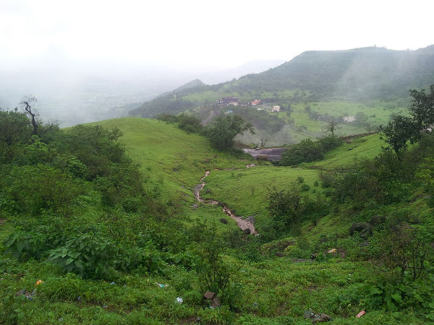

<https://www.nativeplanet.com/img/2017/02/saputara1-16-1487241717.jpg>

* Snuggled in the Sahyadris or the Western Ghats, Saputara is a quaint little hill station in the Dang district of Gujarat. Popular for lush green forests, undulating mountains, dazzling waterfalls, dreamy winding roads, livid landscapes and plenty of charming cubbyholes to spend time with your loved ones, the town is the first favourite among tourists. It is located at a height of 875 metres above sea level and is a perfect getaway for eco-lovers, wildlife enthusiasts and people who love adventure sports.
* Araku valley,Andhra Pradesh

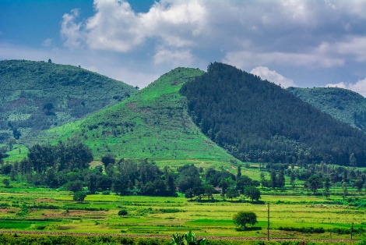

<https://d2rdhxfof4qmbb.cloudfront.net/wp-content/uploads/20200813131424/iStock-1253176292-1024x683.jpg>

* Vizag is a popular tourist destination mainly known for its beaches. Located at a distance of 120 km from Vizag is a beautiful hill station called Araku which is as popular as the beaches of Vizag.
* Blessed with enchanting streams, lush green forests, beautiful waterfalls, sprawling coffee plantations, rich landscape and wonderful weather, Araku valley is no doubt a famous tourist destination attracting nature lovers, honeymoon couples, and adventure enthusiasts from all over the country.
* Somnath, Gurat

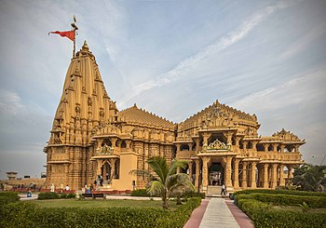

<https://upload.wikimedia.org/wikipedia/commons/thumb/a/ac/Somanath_Temple.jpg/350px-Somanath_Temple.jpg>

* The Somnath temple, also called Somanātha temple or Deo Patan, is located in [Prabhas Patan](https://en.wikipedia.org/wiki/Prabhas_Patan), [Veraval](https://en.wikipedia.org/wiki/Veraval) in [Gujarat](https://en.wikipedia.org/wiki/Gujarat), [India](https://en.wikipedia.org/wiki/India). One of the most sacred pilgrimage sites for the Hindus, they believe it to be the first among the twelve [Jyotirlinga](https://en.wikipedia.org/wiki/Jyotirlinga) shrines of [Shiva](https://en.wikipedia.org/wiki/Shiva).[[1]](https://en.wikipedia.org/wiki/Somnath_temple#cite_note-somnathorg-1-1) Reconstructed several times in the past after repeated destruction by several Muslim invaders and rulers,[[2]](https://en.wikipedia.org/wiki/Somnath_temple#cite_note-FOOTNOTEYagnikSheth200539%E2%80%9340,_47%E2%80%9350-2)[[3]](https://en.wikipedia.org/wiki/Somnath_temple#cite_note-FOOTNOTEThapar200436%E2%80%9337-3)[[4]](https://en.wikipedia.org/wiki/Somnath_temple#cite_note-Catherine_B._Asher,_Cynthia_Talbot_42-4)[[5]](https://en.wikipedia.org/wiki/Somnath_temple#cite_note-5) it is unclear when the first version of the Somnath temple was built. Estimates for the first Somnath temple vary between the early centuries of the 1st-millennium to about the 9th-century CE.[[6]](https://en.wikipedia.org/wiki/Somnath_temple#cite_note-FOOTNOTEDhakyShastri1974-6)[[7]](https://en.wikipedia.org/wiki/Somnath_temple#cite_note-FOOTNOTERosa_Maria_Cimino1977-7) The temple's history is a subject of disputes and remains controversial.[[8]](https://en.wikipedia.org/wiki/Somnath_temple#cite_note-FOOTNOTEThapar2004-8)[[9]](https://en.wikipedia.org/wiki/Somnath_temple#cite_note-FOOTNOTECousens193115%E2%80%9318-9)
* Malshej ghat, Maharashtra

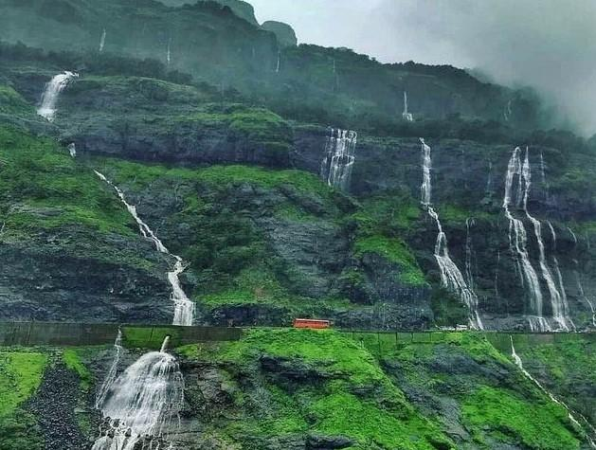

<https://im.whatshot.in/img/2020/Aug/8158b27a9ec7c1b96faed1408c1b5374-1598845319.jpg>

* Malshej ghat, with average height of 700 m[[1]](https://en.wikipedia.org/wiki/Malshej_Ghat#cite_note-mt-1) is situated in Pune district near the border of Pune and Thane districts. It is at a distance of 130 km north of Pune and 154 km from Mumbai towards northeast. The nearest railhead is [Kalyan](https://en.wikipedia.org/wiki/Kalyan,_India) in Thane District or [Karjat](https://en.wikipedia.org/wiki/Karjat" \o "Karjat) near Mumbai. The nearest State Transport Bus Station is at Junnar, Pune. From Kalyan Rail Station, one can take state buses that commute frequently between Kalyan and Ahmednagar. The State Bus Station is right next to the railway station. Any Ahmednagar Bound Bus will stop at Malshej Ghat. It will approximately take 1.5 hrs by Bus from Kalyan. To go to Malshej ghat by road From Pune, take Pune-Nashik highway (NH-50) to Narayangaon and turn the road to Otur which will join on to Kalyan-Ahmednagar Highway (SH-222) towards Kalyan. From Mumbai, take NH3 to Bhiwandi and turn towards Murbad or take state highway via Kalyan, Murbad, Saralgaon and Vaishakhare. It is known for landslides during monsoons
* Alwar, Rajestan – the tiger gate of Rajestan

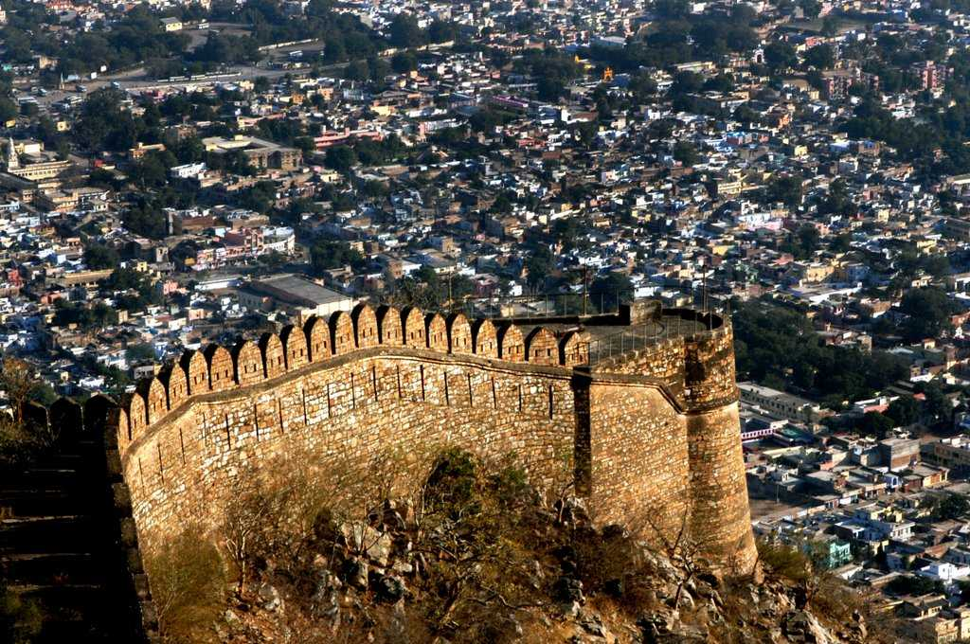

<https://www.holidify.com/images/bgImages/ALWAR.jpg>

* Alwar is the first major city that comes while travelling from Delhi to Rajasthan and is uniquely located at 150 km south of Delhi and 150 km north of Jaipur. Alwar is a hub of tourism with forts like the Bhangarh fort, lakes, nature reserves like Sariska Tiger Reserve and heritage havelis. Apart from being a popular tourist centre, Alwar also draws pride from its reputation of being featured in a number of Bollywood movies. It is also famous for the Mega Alwar Trade fair held at Dussehra Ground every year and handmade Papier-mâché (literally 'chewed paper'). Alwar is also famous for Alwar ka Mawa, a sweet preparation.
* Champaner, pavagadh

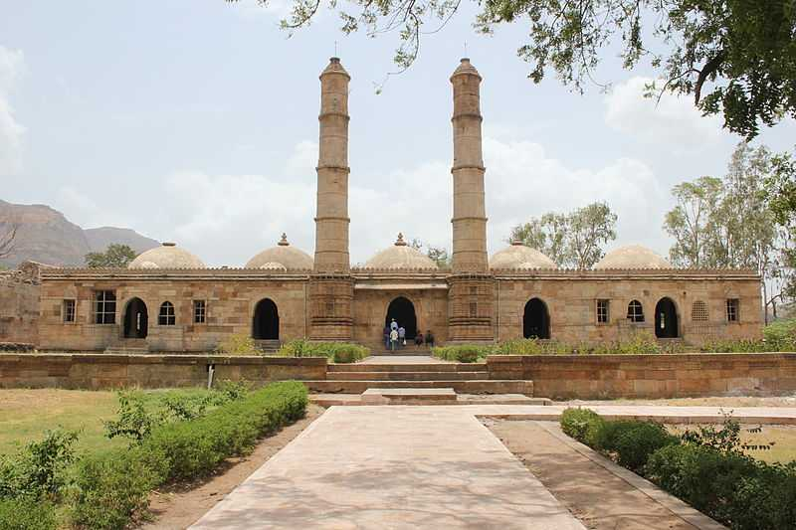

<https://www.holidify.com/images/bgImages/CHAMPANER-PAVAGADH.jpg>

* Champaner-Pavagadh Archaeological Park holds a lot of historical as well as mythological significance in itself. The Park comprises of umpteen number of splendid architectural wonders consisting of both Hindu & Islamic styles of design. Another interesting piece of trivia regarding this place is that the hill of Pavagadh is believed to be a chunk of the Himalayas that was originally carried by Hanuman to Lanka in the Ramayana epic. With such rich history to its name, this makes up for a really intriguing place to visit.
* Dwarka, Gujrat

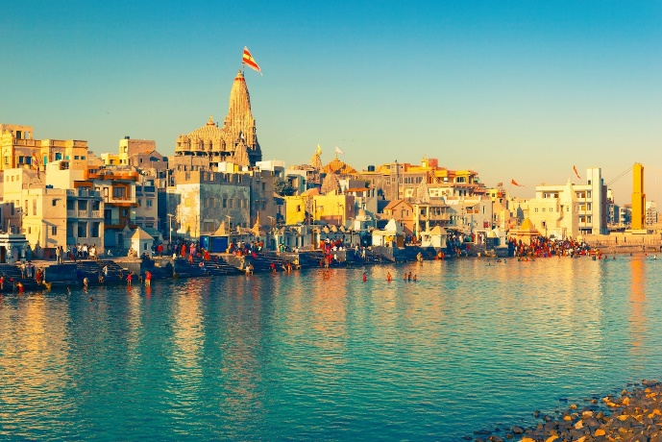

<https://cdn1.goibibo.com/voy_ing/t_fs/jamnagar-dwarka-148824937022o.jpeg>

dwarka is a city and a municipality of [Devbhumi Dwarka district](https://en.wikipedia.org/wiki/Devbhumi_Dwarka_district" \o "Devbhumi Dwarka district) in the [state](https://en.wikipedia.org/wiki/States_and_territories_of_India) of [Gujarat](https://en.wikipedia.org/wiki/Gujarat) in northwestern India. It is located on the western shore of the Okhamandal Peninsula on the right bank of the Gomti River. In 2011 it had a population of 38,873. Dwarka is one of the [Chardhams](https://en.wikipedia.org/wiki/Chardham" \o "Chardham), four sacred [Hindu](https://en.wikipedia.org/wiki/Hindu) pilgrimage sites, and is one of the [Sapta Puri](https://en.wikipedia.org/wiki/Sapta_Puri" \o "Sapta Puri), the seven most ancient religious cities in the country. Dwarka is often identified with the [Dwarka Kingdom](https://en.wikipedia.org/wiki/Dv%C4%81rak%C4%81), the ancient kingdom of [Krishna](https://en.wikipedia.org/wiki/Krishna), and is believed to have been the first capital of Gujarat.

* City palace, Udaipur

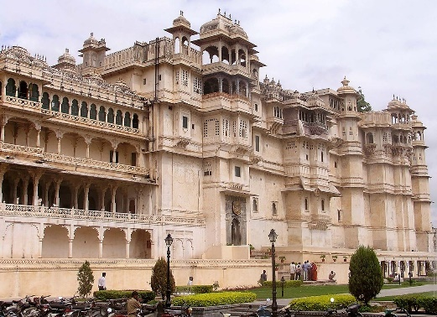

<https://upload.wikimedia.org/wikipedia/commons/thumb/6/69/Udaipur_City_Palace.jpg/1280px-Udaipur_City_Palace.jpg>

* City Palace, Udaipur is a palace complex situated in the city of [Udaipur](https://en.wikipedia.org/wiki/Udaipur) in the Indian state of [Rajasthan](https://en.wikipedia.org/wiki/Rajasthan). It was built over a period of nearly 400 years, with contributions from several rulers of the [Mewar](https://en.wikipedia.org/wiki/Mewar) dynasty. Its construction began in 1553, started by [Maharana](https://en.wikipedia.org/wiki/Maharana) [Udai Singh II](https://en.wikipedia.org/wiki/Udai_Singh_II" \o "Udai Singh II) of the [Sisodia](https://en.wikipedia.org/wiki/Sisodia) [Rajput](https://en.wikipedia.org/wiki/Rajput) family as he shifted his capital from the erstwhile [Chittor](https://en.wikipedia.org/wiki/Chittaurgarh" \o "Chittaurgarh) to the new found city of Udaipur. The palace is located on the east bank of [Lake Pichola](https://en.wikipedia.org/wiki/Lake_Pichola) and has several palaces built within its complex.